Noon Academy

**Noon Academy, a Project of CityNet Co. Ltd**

**Malaz Riyadh**

**PHONE: 00966 14799998**

**FAX: 00966 12065255**

**2/11/2013**

By Kifayat Ullah Khan

Noon Academy is an online tuition and training center in which you can get live interactive sessions with Experts, Teachers and professors on different offered courses. Noon Academy will facilitate the school and university students to master any of their school’s or College’s subject or get Short Training courses from experienced teachers and skilled professionals.

Contents

Introduction 2

1. Home Page 3

2. Available Courses List 4

3. Login Page 5

4. Student Control Panel 6

5. Navigational Menus 7

6. User Profile 8

7. Change Your Password 9

8. Student Control Panel Available Courses List 10

9. Student Enrolled My Courses List 11

10. Student Classes List 12

11. Start of Virtual Class 13

# Introduction

Noon Academy is an online academy providing distance learning facilities and virtual class rooms. We facilitate the distance learning using online means with interactive live session between the teachers and students. We us Internet is a mean for spreading education and facilitating students who are studying in different schools and colleges to have high skilled teacher to teach them any courses or subjects in which they might need extra lessons to master it thoroughly.

In Noon Academy we have the best teaching staff from the local and international schools, colleges and universities. This teaching staff will provide online coaching classes or trainings to the students who are interested in those lessons. It is like you have the best subject specialist teaching to you in your home, using the online virtual class room. You may be joined by other online class fellows so cross questioning of other students will also help you develop more skills in the subject.

To get benefit of the online virtual class room, you can simple register an account on our web site at [www.noonacademy.com](http://www.noonacademy.com) and get started. Choose any courses in which you are interested, and get yourself enrolled to it, after paying the nominal tuition fee your name will be added automatically to the live classes of that specific subject course and you will be able to attend any of the scheduled class. Note that all these classes are live sessions of the course with a real expert teacher and hence give you the facility to interact with the teacher, ask questions, share views, download recorded classes, or library material in the form of e-books etc.

Following are some of the key features that you will find in the online Noon Academy:

1. Online Education with ease of access
2. High Qualified Teachers
3. Home Based Tuition using our Virtual Class Rooms.
4. Download recorded Lecturers and training lessons at any time.
5. Easy Registration process
6. Very affordable and nominal fee structure.

You can also find video trainings on how to use our online learning system on our YouTube channel (<http://www.youtube.com/noonacademysa> ). You can also follow us on twitter and Facebook using our official channel.

A brief introduction with relevant screen shots has been shown below, which will give you clear idea on how to use the application and get yourself ready for your next virtual classes her at Noon Academy.

# 1. Home Page

This is the home page of the web site, with related links to pages and sub pages so you can easily navigate throgh them and get yourself educated in the courses that we are offering for you.

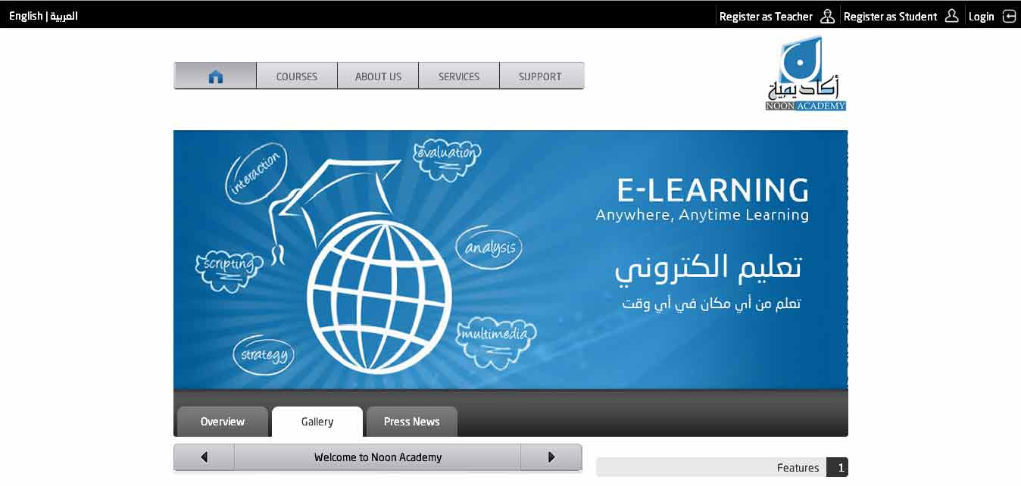

The Home page has links on the top of the page for user account registration and login. We offer two different types of user account registrations:

1. Student Registration
2. Teacher Registration

As these names are self-explanatory, you will be interested to register your account as a teacher. Once you have successfully registered with us as a teacher you can access the control panel and perform all tasks mentioned below.

# 2. Available Courses List

The available *courses list* page shows you any of the courses in any subject that are currently available for student enrollment. The visitor can download the PDF course contents and enroll to the course from this page as a student. Only the students can enroll to the courses offered by any teacher in the system.

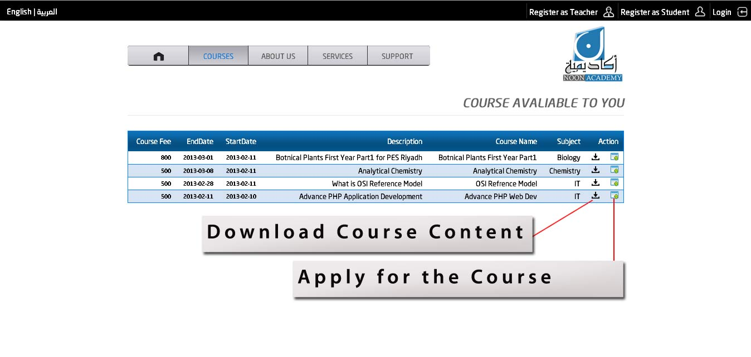

This page is also visible to any guest visitor to the web site without registration or login but if visit want to apply to it, the visitor will need to have a student user account.

# 3. Login Page

The Login page is used to provide application access for teachers and students to access their control panel and perform different activities such as create a course, attend a virtual class, create electronic library etc.

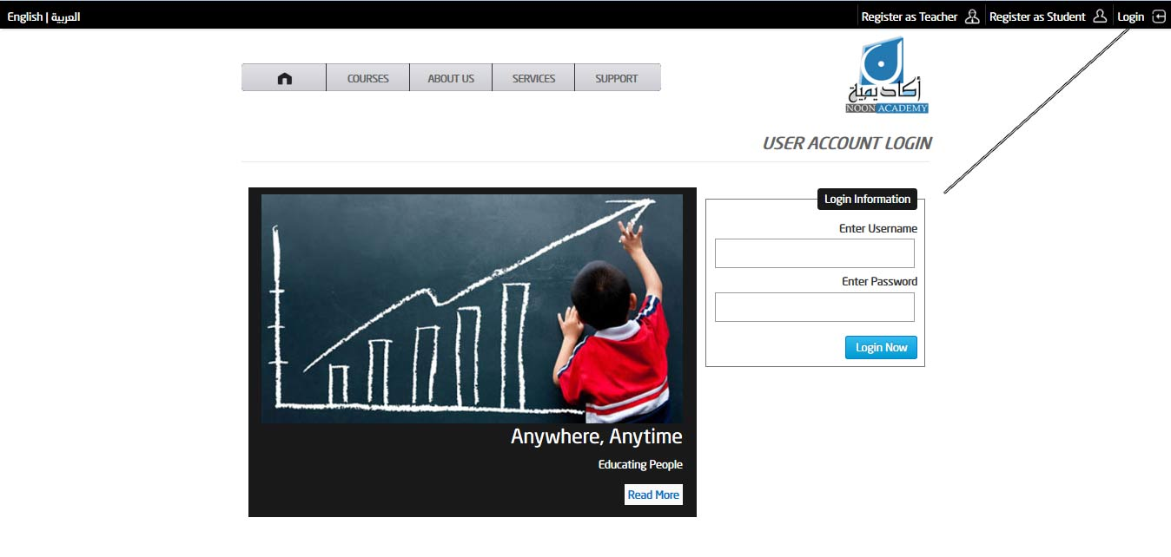

The Username and password can be chosen from the student registration page. Each student has a unique username which could be used to identify every individual student to the system and show him only relevant information based on his selections and choice.

# 4. **Teacher Control Panel**

Teacher Control Panel (cPanel) is a one point ease of access dashboard where a teacher can perform certain tasks. When the teacher login with his username and password he gains access to this control panel, where he can update his profile information, view the list of available courses and create new electronic library, upload files to his libraries, create new courses, enroll student to his courses, schedule classes and add attendants to any of his class for any course he may want.

After enrolling for any course the student is required to pay the tuition fee using any of the payment methods what we offer.

Once the payment is cleared the student name will be automatically enrolled to the classes of the selected paid courses, and hence he will be able to attend those classes as per schedule.

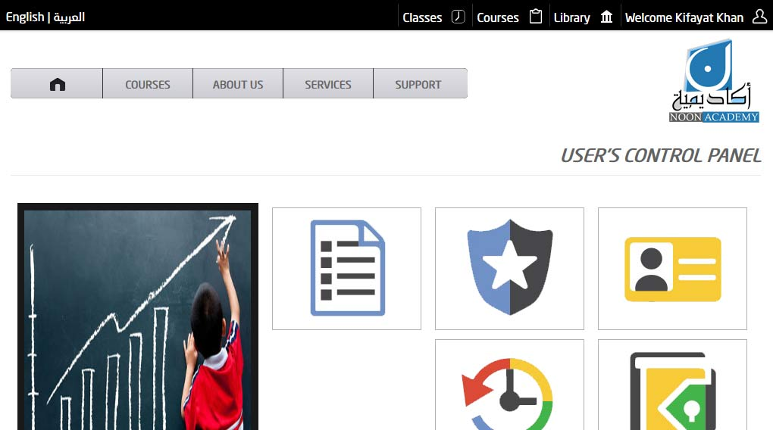

Note that a teacher account is only authorized to create virtual classes once he has done proper agreement with the Noon Academy, and his account has been upgraded. If you want to upgrade your account you will need to contact the administrators at the Noon Academy.

# 5. Navigational Menus

The control panel has both the navigational menus and the Category Tiles which provide the selection of the desired pages you may want to navigate. The Top Navigation menu is a drop down menu and you will be required to hover mouse on any of the top menu item in order to make the sub menu become visible.

To navigate to any page just click on the navigation link and the desired page will be loaded. You can form all the authorized actions using the navigation menu.

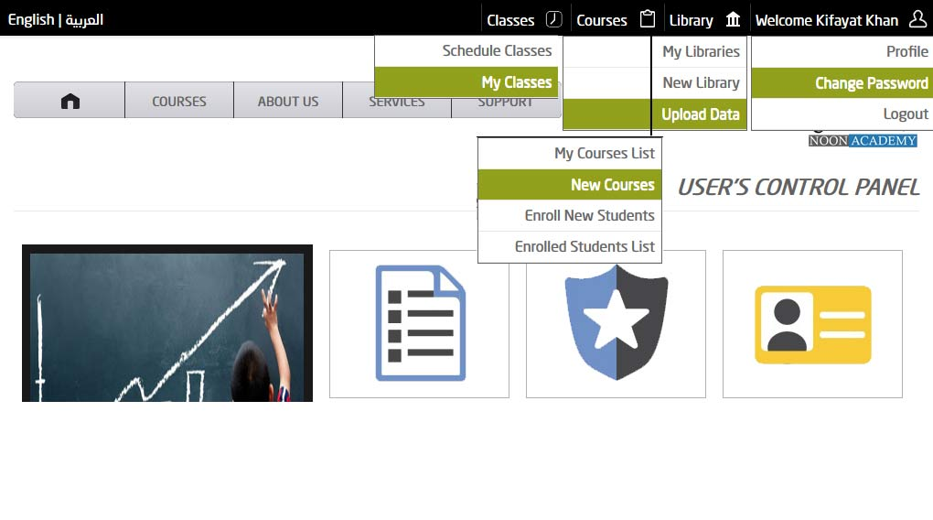

# 6. User Profile

The User profile can be easily access from the top navigation bar, and hence the user can view/update his/her personal information such as his name, email, phone, address, etc.

This page also provides the facility to upload your image, so that you can personalize the looks and feels of the user account itself.

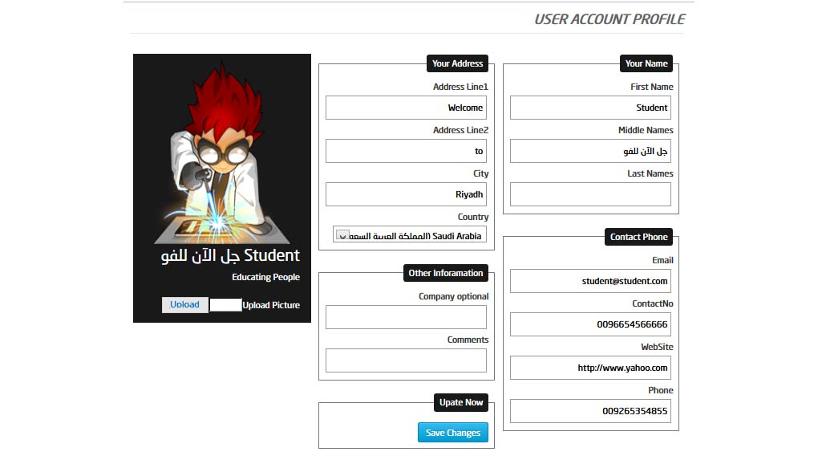

Note that if you want to change the email address, you must inform the Noon Academy of the changes, as this email address needs to be added to the Virtual Classes Application and hence only update them if you really need to.

# 7. Change Your Password

We recommend that you must change your password periodically and keep it secret and secure as this is very important to you, and the system identifies you with these credentials. Try to use hard to guess passwords, and if possible make them a combination of mix letter and characters etc. Never use your name, car registration number or any other personal information that your friends and colleagues might know about you, in order to minimize the risk of your password being stolen or miss used.

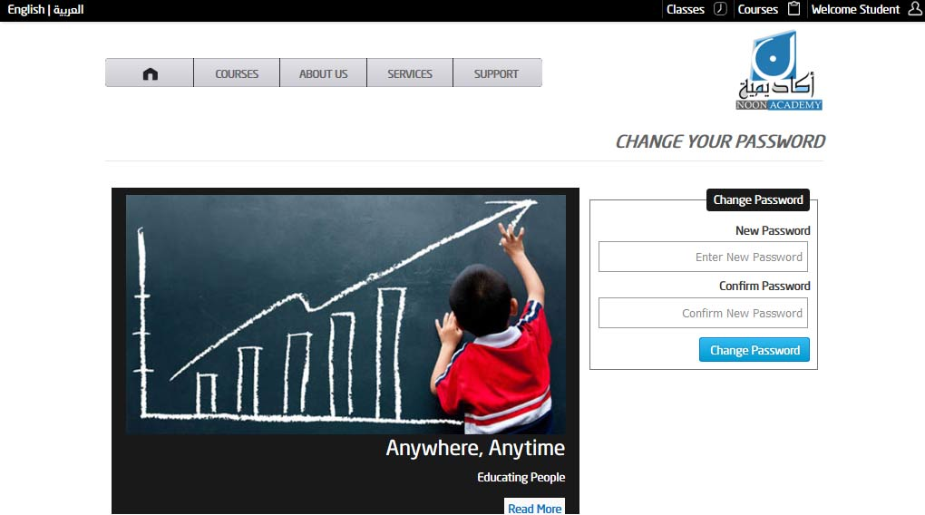

# 8. My Library

We have provided the facility to every teacher to keep his own digital library of electronic documents. The teacher can have one or more libraries, and we suggested that you create a separate library for every course that you are planning to conduct on Noon Academy. By organizing your documents, PDF files, and other electronic material into separate libraries you will gain the benefit to restrict access to the library items download only to registered students.

Note that each course can have only one library, and that library can have multiple electronic data files and PDF etc.

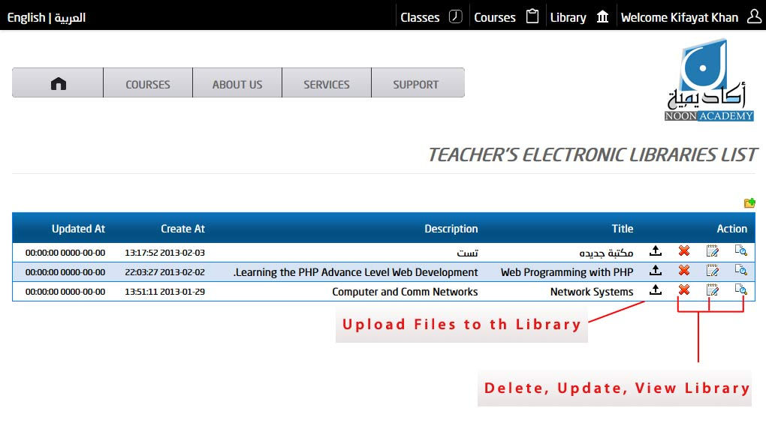There are certain actions that a teacher can perform in the library section of the application.

* View My Library
* Create New Library
* Upload Data to the Library

# 9. Create New Library

You can create new library by selecting ***Library*** *🡪* ***New Library*** from the navigation menu. You can give a name of your choice and some short description to create your library. Once the library is created, you can then upload electronic data files to it using you upload data page.

# 10. Update Files to the Library

You can upload files to the library by navigating to the ***Library 🡪 Upload Data*** page from the top navigation menu or the library list page from the ***My Library*** Page.

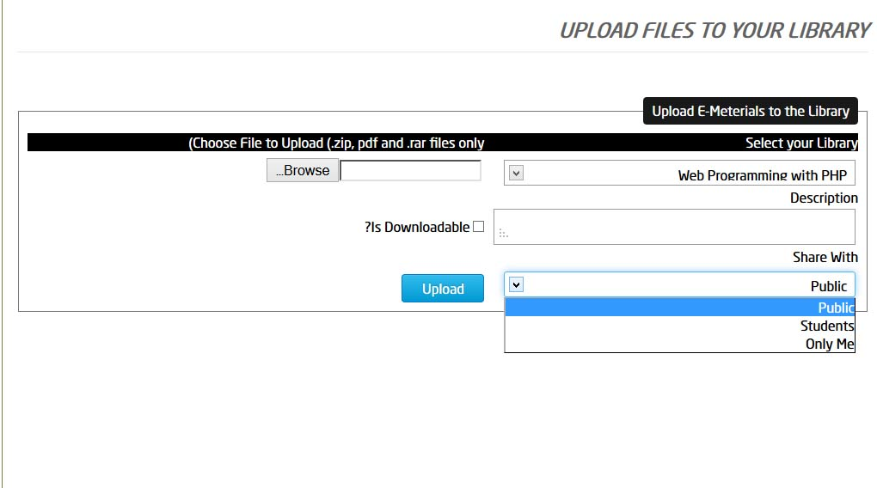

When you are upload files to the library you can select the name of the library to which you want to upload the file and set its sharing level. There are three sharing levels

1. Public
2. Student
3. Only Me

If you make a document ***Public*** share, everyone will be able to download the file even if he is not enrolled or registered to your course.

If you make it ***Student***, any enrolled student with paid status will be able to download the files.

If you set it to ***Only Me*** then the file becomes private to you only and now one is allowed to download it.

# 11. Library Detail View

You can view the details of the library by navigating to the specific library from the library list page by clicking view icon as shown in section ***8. My Library***.

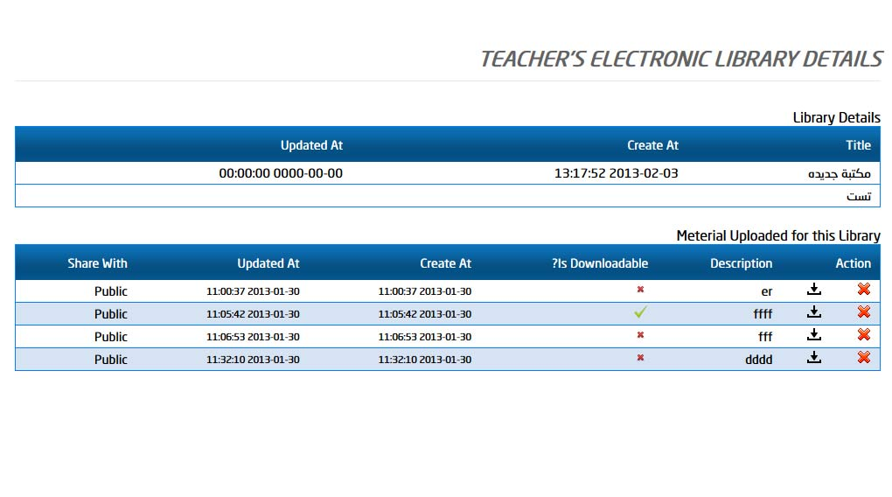

From this page you can delete any uploaded data file or download it to your computer just in case you might need it. You are not providing any additional update feature on the page.

You can delete any file and re-upload it with different name, description or share with settings.

# 12. Teacher Courses List

In this page you will be able to view all of your own courses. The page show two types of listings one list will show you the courses that are currently active and valid for enrollment for the students. The second list will show you that your courses which are now expired and are no longer available to the students for enrollments.

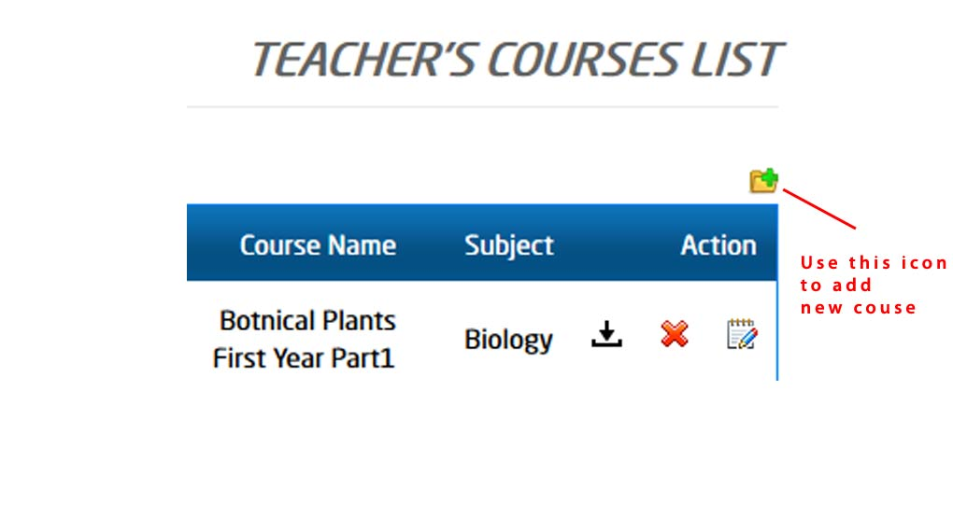The active courses can be deleted or updated and also you can download its course content if you may need them, while the expired courses only show the download file icon. 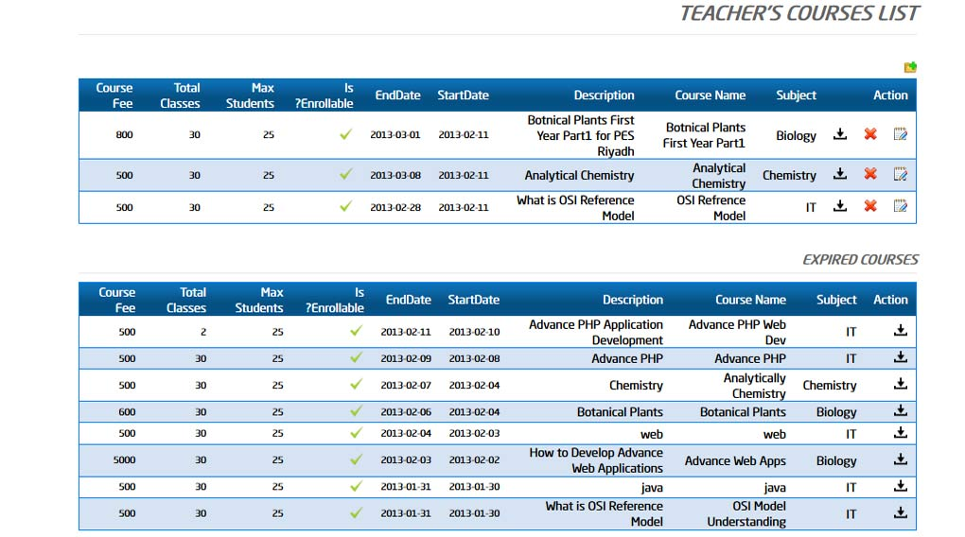

# 13. Teacher Courses List

The ***new course*** page allows you to create new courses that you want to offer. When you want to define a course you will need to understand the following parameters that you will need to associate with your course.

* **Subject-** you need to define under which subject your courses will appear, Subjects can only be added by the administrator and you can only chose it while registering a new course.
* **Teachers Library-** shows you the list of your libraries and you can chose only one from it.
* **Course Name-** is used define a relevant name for the course, the students will see this name while enrolling to it.
* **Description-** is a short detail about the nature of or structure of the course.
* **Start Date-** is used to define when the course will start; it will also be used in the automatic scheduling of the virtual classes of the course.
* **End Date-** is used to define the date on which the course will end and will be removed from the active courses list. When a course End Date passes the course will automatically move to the expired courses list and will no longer be available to the students for enrollments.
* **Content Data file-** is used to upload the course content which the students can download and see that what topics will be covered in the course.
* **Course Fee-** is the amount of fee the student needs to pay for the course if he want to attend the classes. Our system charges the student for the whole courses and not for the classes he want to take.
* **Max Student–** The Max student sets the limit on the number of student that can enroll to the course, currently we allow only 25 students per course as a maximum, but in future we can revise this number.
* 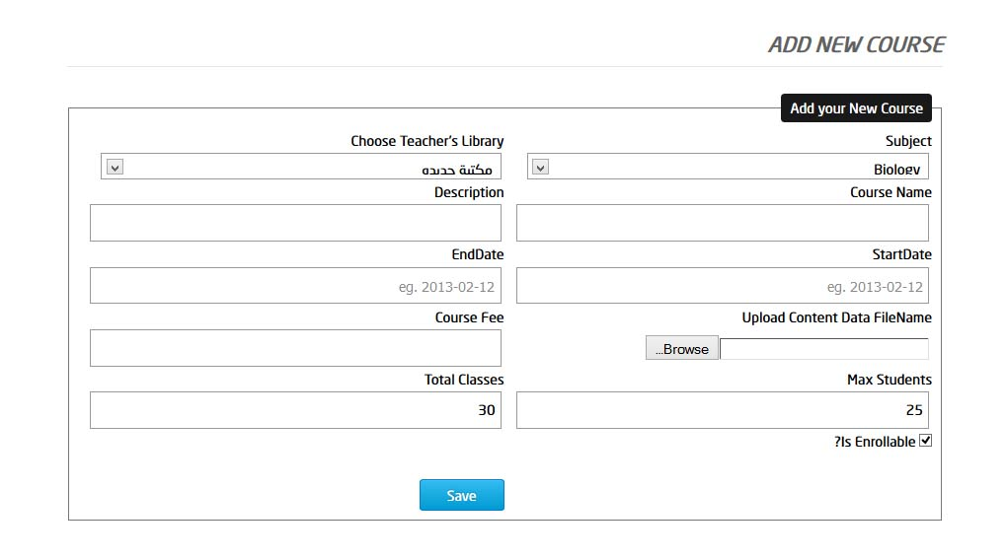**Total Classes –** is used to set a limit of the number of classes from the course. We use this parameter as option at the time, but will become compulsory in the next version of our application.

# 14. Enrolling Student to your Course

In this page you have to choose the course to which you want to enroll the students. This page is for administration purpose only and if the stuent can not himself register himself to then you can do so on his behalf and put his name under yourougcourse.

Note that even if you enroll a student , the student still needs to pay his tution fee through the administrator using the payment chnnels and only then his name will be elegiable for attending the virtual classes.

The enrolling process in down is done in the following steps.

* Chose the from the list of your active couses
* Check the names that you want to enroll to your course, remembr that while adding students to your courses the system will automatically

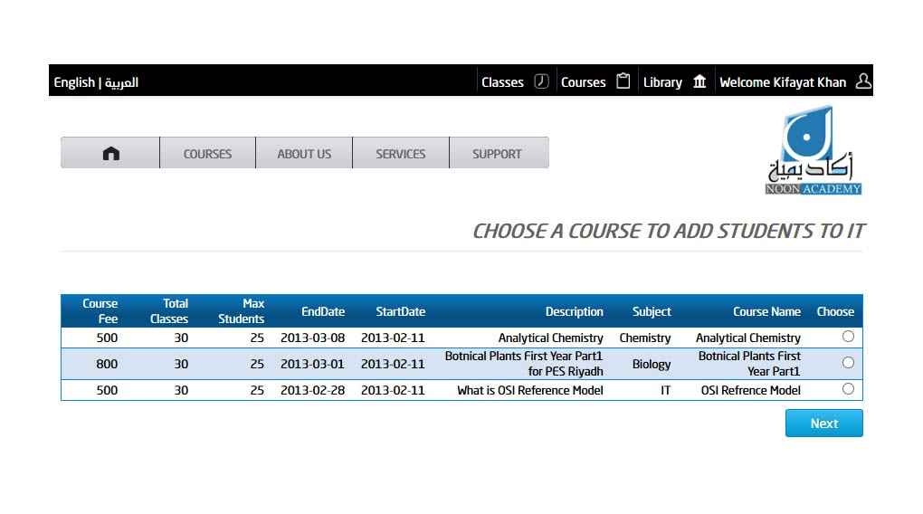

In this next page you have to select the names of the students you wish to add to your course by checking their names and clicking the save button.

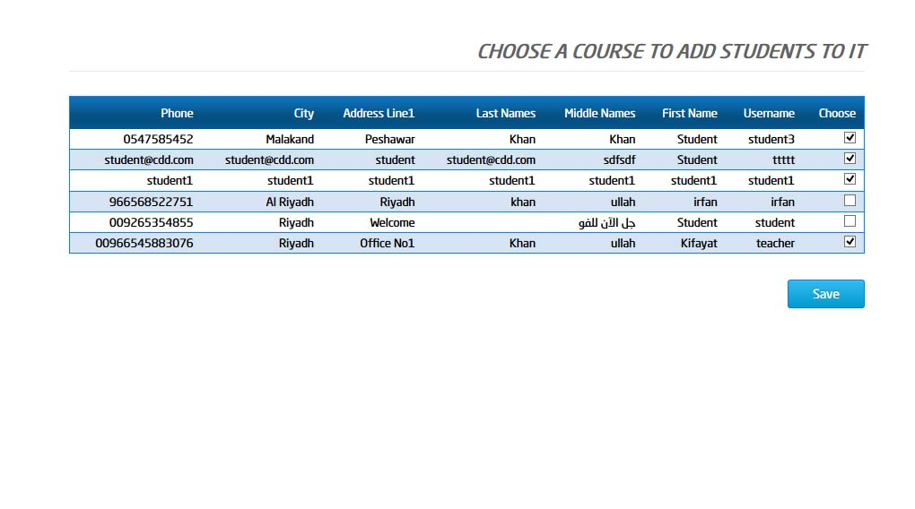

This process is equivalent to the enrollment of a student for a course from the student control panel and as explained earlier that the enrolled students must be authorized by the administrators to be able to attend the classes. Only the student who actually pays the course fee will be eligible for the attendance of the virtual classes.

The list below can be accessed from the navigation menu ***courses 🡪 enrolled student list*** or when you add multiple students to your particular course.

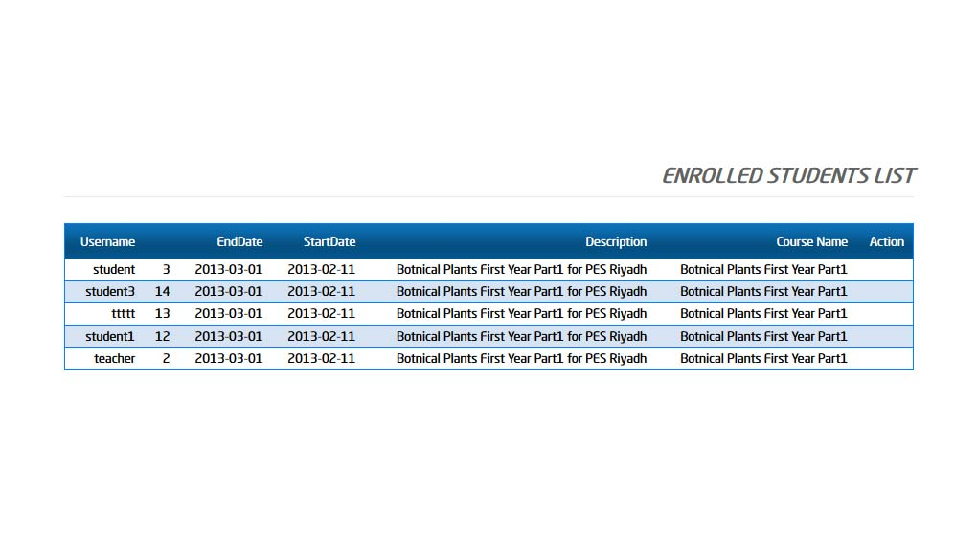

# 15. Create Virtual Class for your courses

The Classes menu from the navigation top bar is used to schedule new virtual classes or start an existing virtual class. The creating virtual classes are a two-step process, in step one you need to do the following:

1. Choose the title (name) of the course
2. Choose the time on which you want to start the class
3. Choose the duration of the class (45 Minutes or 60 Minutes)
4. Choose the week days on which you want the class
5. Click on the create schedule.

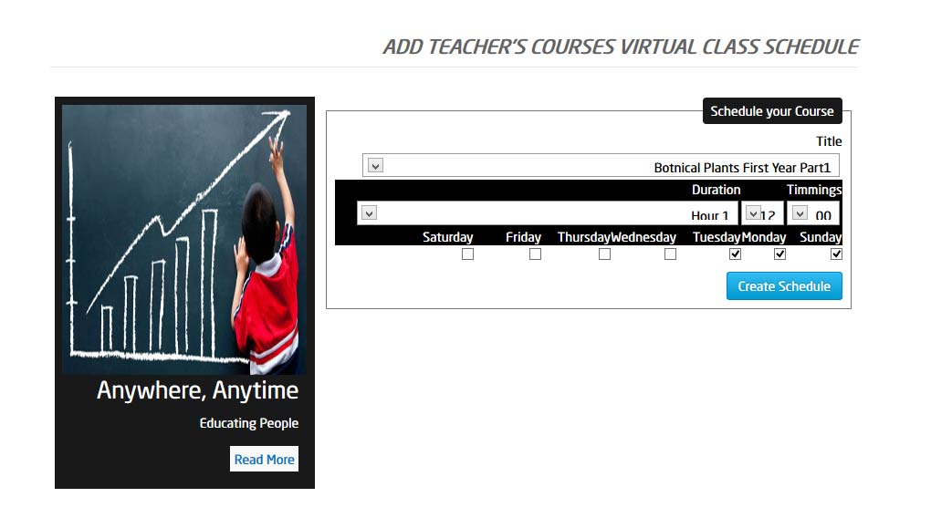

When you click on create the schedule button the system will take you to the next page which is the second step of scheduling the virtual classes on the application.

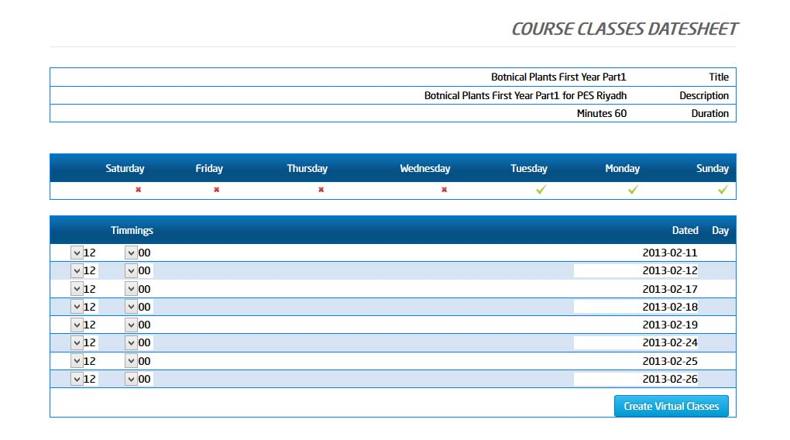

# 11. Start of Virtual Class

When you click on the Join Class Link the classes’ list page, your web browser will open a new page shown as below; this is the virtual classes application through you can attend the class being held. A snapshot of the virtual class is shown below in which you can see the teacher taking a class and the students attending it.

